Milestone 3

Andre Tabourian
Chloe Avedissian
Youssef Jaafar
Sarah Baalbaki

Data Preparation and Feature Engineering

Extra Data Cleaning
For data preparation and feature engineering, we start by additional cleaning of our newly formed dataset (after milestone 2).

For many of the columns in the soil part of the data, we observe some irregularities that are due to the imputation method used (from a very low amount of data, we extrapolated based on existing values).

Those values seem to always occur at the extremes, while values between 10% and 90% seem to be regular. It might therefore be a good idea to explore the possibility of outlier removal.

For the slope value, this value should represent a percentage. Since those values were imputed, we should make sure that no values are below 0 or above 100.

Since most of the values in this column were imputed, and that they mostly seem wrong with a mean of 63 which is extremely high (30% could be considered to be mountainous terrain), we choose to remove this column.

However, later on, we might choose to add this column again by imputing the values we have for the records of every year. The slope from year to year does not change a lot (one must pay attention that over long periods of time it does though).

The whc is also a percentage, so no negative values are allowed, or any value above 100.
We can see that while some soils have a value less than 0, only 1% of them have a value less than 12%. Therefore, we can assume that the imputation was somewhat reasonable (especially with a mean of 24% and std of 5).

If further checking is needed, heavily used lands will tend to see a slight downward trend in whc over time. This can be done if we find that the predictive ability of our models do not translate well into the testing set, or if it does not work well in the real world. In this case, we could assume constant values for whc.

As for the pH, we can see that the min value is 2, which is almost impossible for soils. Even at 1%, a value of 4.7 is very low. We therefore choose to cut the pH off at 1%. At the higher end, a value of 8.9 seems to be alright.

For OM (Organic matter), no negative values should be allowed, and high values should be accounted for. We choose to cut off at every value between 0.1 and 0.9.

As for the rest of the dataframe columns, all of the other values seem to be alright within the bounds of reason.

Splitting Data to Training and Testing

We split the data to training data and test data, with a split of 80% for training and 20% for testing. We do so before rescaling, standardizing, and feature selection and engineering so that we ensure no data leakage between training and test data.

Rescaling

After splitting our data, we can now rescale each batch individually so we ensure that no data leakage occurs.

For the columns sand silt and clay, those values are percentages where the sum of sand+silt+clay should be equal to 100. Of course because those values were mostly imputed so this is not the case in this dataset. However, they are relatively close to 100.
Since this is the case, it is not a good idea to apply standardization or normalization. What we choose to do in this case is rescale by dividing by 100. This will give a value between 0 and 1, while keeping exactly the relative orderings and scalings between those 3 columns.

The spH column will be rescaled according to its definition, any value of pH is between 0 and 14. One of the reasons we choose to do this, is that the pH is placed on a logarithmic scale, therefore changing the relative differences between values will mess up this scale. While there are techniques to mitigate against such actions, the fact that an easy boundary of 14 can be found makes it un-necessary to utilize such techniques.

The whc (water holding capacity) column describes in terms of percentages the amount of water that can be held by the soil in question. In this case, while we could use another technique, the rescaling is quite straightforward.

In the case of kffactor and the kwfactor, those values are already between 0 and 1 and do not need any rescaling.

For the tfactor, organic matter, yearly precipitation, yearly average temperature, and value of previous year, the range of those values are unbounded, and feature no maximum and minimum values. We therefore, choose to standardize those values. This works since we can correctly identify a mean and standard deviation for each sample. Of course, doing it this way requires re-training over time, as the weather and soil behaviors and content change drastically with time. For example, for temperature and precipitation those values change over time with climate change, and are notoriously unpredictable.

Feature Engineering

Feature Crossing

Some features are stronger if they come together, and so crossing combinations of features can provide predictive abilities and insights beyond the ones that these features individually provide. So, we decide to create a new synthetic feature by multiplying (crossing) two or more features.

We decide to do so with the sand, silt, and clay features as they are interdependent on one another. We create a new column that uses propositional logic and takes these 3 variables into consideration, creating a new variable.

Precipitation and temperature may also have a good effect when combined together, so we will cross them and see their effect when training our models.
Sometimes, numerical features cause changes based on certain thresholds. But in our case, all our values are numerical and the tiniest variation may impact the model a lot, so we decide to keep our values as they are and not encode them or set thresholds for them.

Feature Encoding

On the other hand, we may be able to create a feature to represent the FIPS value. The FIPS values uniquely identify geographic areas, where the first first two digits are the FIPS code of the state to which the county belongs, and the following three are for the county itself. The FIPS values are an important factor because they indicate and identify geographic areas, which can hold information within them (such as soil type, vegetation, climate and weather data..) that may not be directly addressed but may be characteristic to a state or drop of states. So, we decide to create a new feature of the states by encoding them using binary hot encoding (they become numerical) and thus we will be able to embed them in our models. We decide to use biary hot encoding because other forms of encoding such as label encoding or ordinal encoding may give a false insight to a rank or importance for the values that is not truly present, and that we would not like to reflect in our odel so that it doesn’t bias the answers.

We will also keep a column of the state names as strings, where that can be used in the case of a decision tree where not all values have to be numerical, and we can have categorical ones as well.

Feature Creation

We also choose to create a new columns that represents the value of the previous year. This idea permits us to dissociate the dataset from the notion of time. We choose to drop columns with na values for previous years for two reasons. The years represented in such classes are typically the first year a record was taken, and should not affect subsequent records. Second, imputing a value for this column does not make sense as this column is essentially the same as the column we are trying to predict.

Data preparation and Feature Engineering Summary:

Rescaling based on upper limit | Done for pH, sand, silt, clay, and whc
Standard scaling | Done for the other columns
Feature Crossing | Crossing done for Weather and sand, silt and clay
Binary Encoding | The FIPS column is decomposed into two columns that are each binary encoded
Feature Creation | Creates a column representing the value of the previous year

Feature Selection

Feature Importance: XGBoost
A benefit of using gradient boosting is that after the boosted trees are constructed, it is relatively straightforward to retrieve importance scores for each attribute.

We decided to start performing XGBoost on our model, to be able to get the importance of providing a score that indicates how useful or valuable each feature was in the construction of the boosted decision trees within the model.

We started with a XGBoost Model which automatically calculates feature importance on the predictive modeling problem.

We then plot the results from the XGBoost Model. In the screenshot below, we can see that the top features are:

Value of previous year, yearly precipitation and crossed weather. The figure shows the top F scores highlighting the importance of our features.

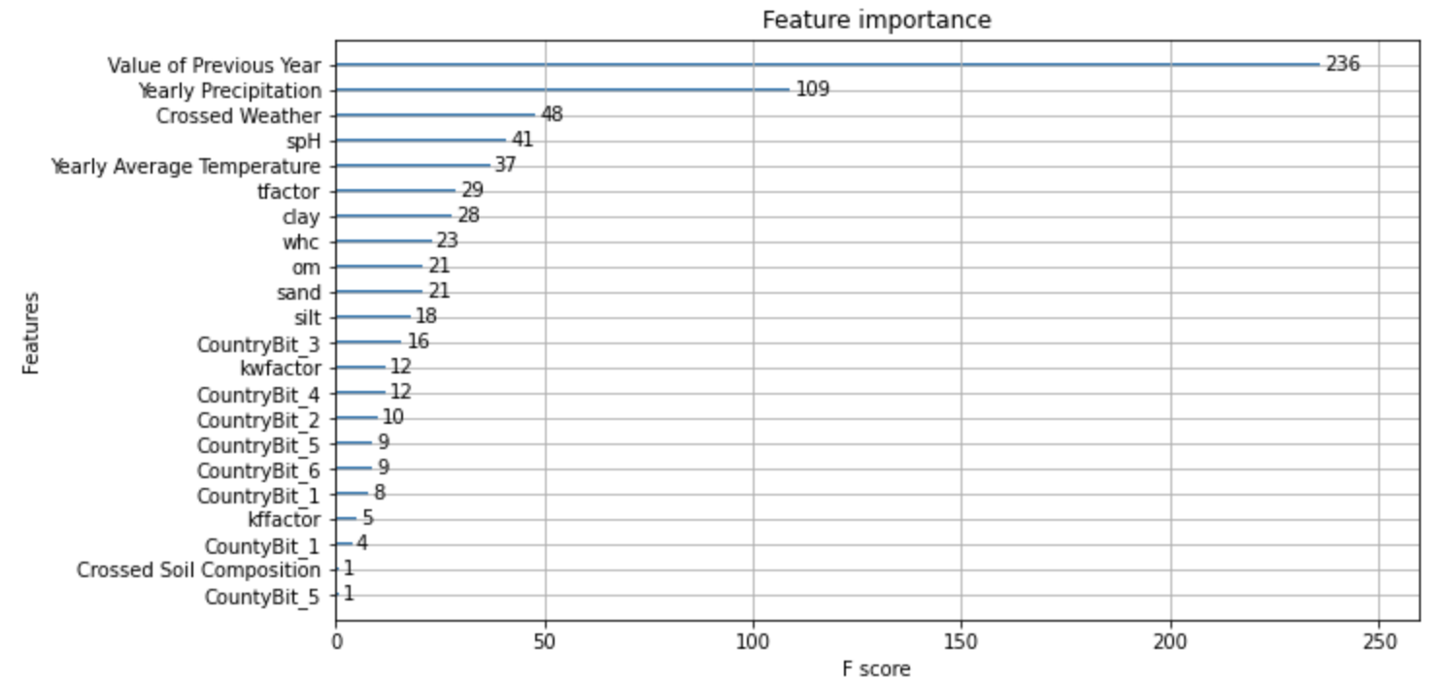

Feature Importance: Extra Trees
Tree-based estimators can be used to compute feature importances, which in turn can be used to discard irrelevant features. In this case, we used Extra Trees on our model to be able to pinpoint which are the relevant vs. the irrelevant features.

The results below show us the features that scored the lowest, are the most irrelevant features for our study:
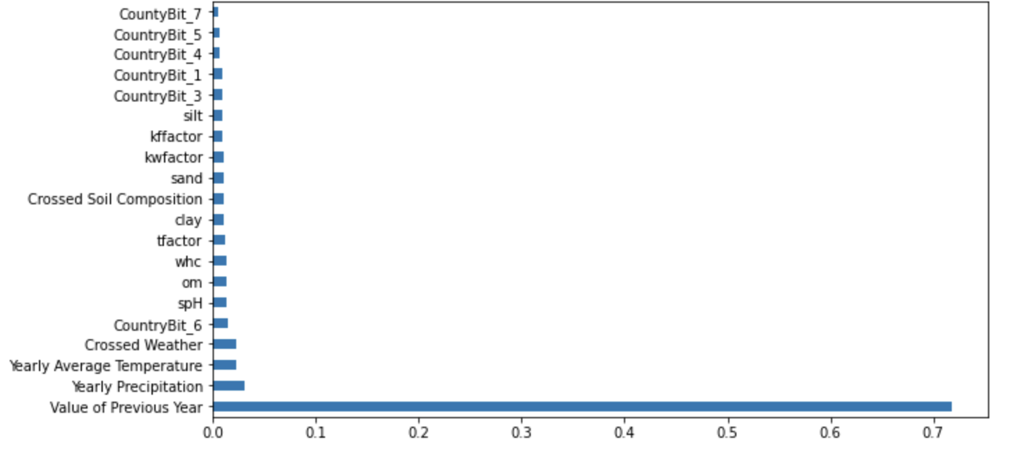

Feature Selection with XGBoost and Extra Trees's Feature Importance Scores
The goal is to create a model and transform our dataset into a subset with the selected features.
This is why we started by transforming X_train and X_test into subsets of the selected features only, and then we initialized a new extra trees model on our new data to be able to evaluate the predictions of the model on the new subset of selected features on the testing using MAE.

We use the features shown in the graph above, and get the following MAE scores:
MAE: 6.00857

This score is relatively low (and in some cases much lower) to later MAE scores we will see (further in the report) indicating that the model performs better and there is less prediction error when we fit it on the more important selected features.

Univariate Feature Selection
We then performed an univariate feature selection on our model. This works by selecting the best features based on the univariate statistical tests (ANOVA). The methods based on F-test estimate the degree of linear dependency between the two random variables. They assume a linear relationship between the feature and the target.

We used univariate feature selection to be able to pinpoint the different degrees of linear dependency between the two random variables on our features. We then plotted our results.
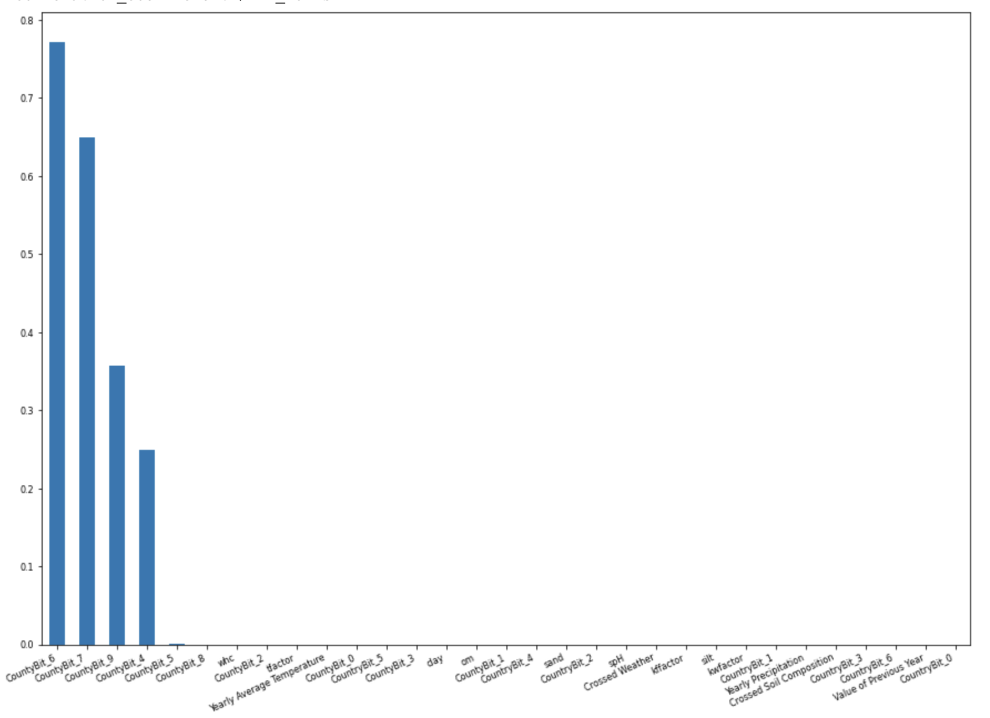

Recursive Feature Elimination
We decided then to perform the recursive feature elimination on our model because it is effective at selecting the features (columns) in a training dataset that are more or most relevant in predicting the target variable.

The resulting selected features from the recursive feature elimination are:

Selected Features: ['whc', 'sand', 'silt', 'clay', 'om', 'kwfactor', 'kffactor', 'spH', 'tfactor', 'Yearly Precipitation', 'Yearly Average Temperature', 'Value of Previous Year', 'Crossed Soil Composition', 'Crossed Weather', 'CountryBit_4']

We can see that most of the county bits were left out and not selected, in addition to the soil components and temperature data being main important features (seeing as they were selected to keep).

Principal Component Analysis (PCA)
Reducing the number of input variables for a predictive model is referred to as dimensionality reduction. Fewer input variables can result in a simpler predictive model that may have better performance when making predictions on new data. Perhaps the most popular technique for dimensionality reduction in machine learning is Principal Component Analysis. This is why we next decided to perform PCA on our model. Below are the results from the PCA:

PCA nb of components: 1 - MAE: -16.104 (0.145)
PCA nb of components: 2 - MAE: -14.210 (0.129)
PCA nb of components: 3 - MAE: -9.731 (0.100)
PCA nb of components: 4 - MAE: -9.238 (0.090)
PCA nb of components: 5 - MAE: -8.279 (0.075)
PCA nb of components: 6 - MAE: -8.048 (0.085)
PCA nb of components: 7 - MAE: -7.987 (0.080)
PCA nb of components: 8 - MAE: -8.023 (0.079)
PCA nb of components: 9 - MAE: -8.029 (0.079)
PCA nb of components: 10 - MAE: -8.044 (0.091)
PCA nb of components: 11 - MAE: -8.042 (0.086)
PCA nb of components: 12 - MAE: -8.048 (0.081)
PCA nb of components: 13 - MAE: -8.052 (0.080)
PCA nb of components: 14 - MAE: -8.027 (0.085)
PCA nb of components: 15 - MAE: -8.021 (0.081)
PCA nb of components: 16 - MAE: -7.996 (0.083)
PCA nb of components: 17 - MAE: -8.002 (0.081)
PCA nb of components: 18 - MAE: -8.003 (0.073)
PCA nb of components: 19 - MAE: -7.974 (0.070)
PCA nb of components: 20 - MAE: -7.974 (0.087)

A lower MAE is desired because it measures how much difference there is between actual and predicted values, and we want the least difference corresponding to the most accurate results. So, we can see that with 16, 19 or 20 components, we get the best results. This shows that using more components and features is important in our case because they all have an added value for the model performance.

SelectKBest: Mutual information Regression
We decided to perform another feature selection using the Method SelectKBest, where we select the k best performing features, depending on mutual information Regression. In this case, to select our best features, we focus on features that have mutual information and correlation with others. This allows us to check the amount of mutual information statistics for all input variables to understand how variables change together.

Performing it on our model, we received the top 20 features below with their scores:

Feature_Name Score
11 Value of Previous Year 0.780918
7 spH 0.150086
2 silt 0.124292
1 sand 0.100419
6 kffactor 0.098425
5 kwfactor 0.097006
12 Crossed Soil Composition 0.092444
3 clay 0.083981
4 om 0.076942
10 Yearly Average Temperature 0.076390
0 whc 0.074928
8 tfactor 0.072716
9 Yearly Precipitation 0.069528
20 CountryBit_6 0.047312
13 Crossed Weather 0.039356
17 CountryBit_3 0.039332
15 CountryBit_1 0.035441
19 CountryBit_5 0.034164
16 CountryBit_2 0.028693
22 CountyBit_1 0.013455

Feature Selection - Top Features

Method | Top Features Selected
XGBoost | Value of Previous Year, Yearly Precipitation, Crossed Weather, spH, Yearly Average Temperature
Extra Trees | Value of Previous Year, Yearly Precipitation, Yearly Average Temperature, Crossed Weather, CountryBit_6
Univariate Feature Selection | CountyBit_6, CountryBit_7, CountyBit_9, CountyBit_4
Recursive Feature Elimination | 'whc', 'sand', 'silt', 'clay', 'om', 'kwfactor', 'kffactor', 'spH', 'tfactor', 'Yearly Precipitation', 'Yearly Average Temperature', 'Value of Previous Year', 'Crossed Soil Composition', 'Crossed Weather', 'CountryBit_4'
SelectKBest Mutual information Regression | Value of Previous Year, spH, silt, sand, kffactor, kwfactor

The models gave us some different outcomes for less important features, but for the main primary features, In most of the models, the previous year value was of much importance, in addition to temperature and precipitation data, and some of the soil components (spH, silt).

The only model that gave us completely different results is Univariate Feature Selection, which studies the statistical significance between the relationships of the target features, and it gave us county_bits for the selected ones.

Models fit

Regression Tree and Regression Boosted Tree (Gradient Boost)

First Fit

We use DecisionTreeRegressor for the regression tree model which is embedded using a decision tree.

There are 4 leaf nodes in our tree. This is because we set max_depth=2. The number of leaf nodes is equivalent to 2^max_depth.

The hyperparameter max_depth controls the complexity of branching. In this case where max_depth=2, the model does not fit the training data very well. This is called the problem of underfitting.

When we create the best model, we should avoid both underfitting and overfitting conditions.

So, what is the best value for the hyperparameter max_depth? Finding out the optimum value (not too small or too large) for max_depth is called hyperparameter tuning.

We train the model using X_train, y_train and test it using X_test, y_test. This is done for different values of max_depth hyperparameter ranging from 1 to 20 and we plot the testing error with the training error.

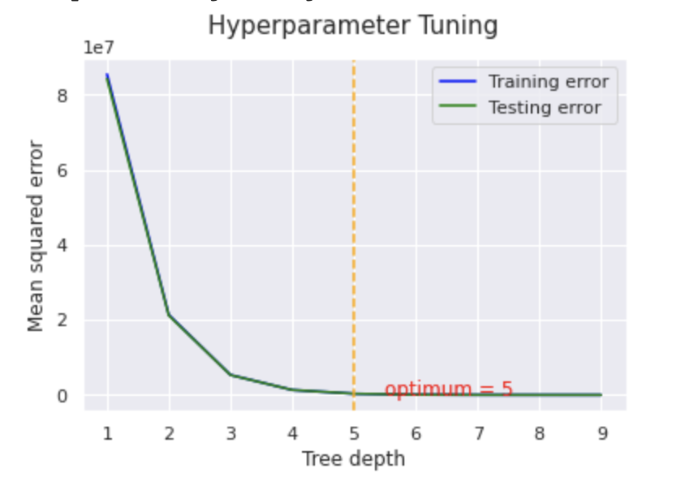
We find that the optimum tree depth is 5.

Cross Validation

Cross-validation is a resampling procedure used to evaluate machine learning models on a limited data sample.

The procedure has a single parameter called k that refers to the number of groups that a given data sample is to be split into. As such, the procedure is often called k-fold cross-validation. When a specific value for k is chosen, it may be used in place of k in the reference to the model, such as k=10 becoming 10-fold cross-validation.

Cross-validation is primarily used in applied machine learning to estimate the skill of a machine learning model on unseen data. That is, to use a limited sample in order to estimate how the model is expected to perform in general when used to make predictions on data not used during the training of the model.

It is a popular method because it is simple to understand and because it generally results in a less biased or less optimistic estimate of the model skill than other methods, such as a simple train/test split. The picture below shows an example of 5-fold cross validation:

The general procedure is as follows:

1.Shuffle the dataset randomly.
2.Split the dataset into k groups
3.For each unique group:
3.1. Take the group as a hold out or test data set
3.2. Take the remaining groups as a training data set
3.3. Fit a model on the training set and evaluate it on the test set
3.4. Retain the evaluation score and discard the model
4.Summarize the skill of the model using the sample of model evaluation scores

Importantly, each observation in the data sample is assigned to an individual group and stays in that group for the duration of the procedure. This means that each sample is given the opportunity to be used in the hold out set 1 time and used to train the model k-1 times.

Hyperparameter Tuning

Unlike model parameters, which are learned during model training and can not be set arbitrarily, hyperparameters are parameters that can be set by the user before training a Machine Learning model. Examples of hyperparameters in a Decision Tree are the maximum number of features to consider at each split or the maximum depth of the tree, etc.

One of the most popular approaches to tune Machine Learning hyperparameters is called GridSearchCV() in scikit-learn. We start by creating a grid of hyperparameters we want to optimise with values that we want to try out for those hyperparameters.

GridSearch takes a dictionary of all of the different hyperparameters that you want to test, and then feeds all of the different combinations through the algorithm, and then reports back to you which one had the highest score. As its name suggests, it basically does a cross validation for each combination of hyper parameters. This is why, if we go back to the picture above, we can see all the splits annotated by "Finding Parameters". With that being said, each combination of hyper parameters will have its own cross validation score, and the best combination of hyper parameters is, therefore, the one with the best cross validation score.

Data Leakage in Hyper Parameter Tuning Incorporating Cross Validation

GridSearchCV (or any other paradigm involving cross validation) must be done on the training data. This means that, if we scale our data using MinMaxScaler() or StandardScaler() for example, and then pass that scaled data into the GridSearchCV, data leakage will occur because, in a 5-fold cross validation scenario, in each of the 5 splits, 4 groups of the data in each split will be considered for training, and one group in each split will be considered for evaluation.

Eventually the data from the validation has leaked to the training because we passed in the scaled data before splitting into train/validation.

In order to avoid the data leakage scenario, we define a pipeline using make_pipeline with MinMaxScaler() being the first operation in the pipeline, and DecisionTreeRegressor() being the second operation in the pipeline. This will ensure that in each fold, the MinMaxScaler() will be fitted on the training portion, and then will be used to transform the validation portion using the statistics calculated from the training portion.

model_dtr = make_pipeline(MinMaxScaler(), DecisionTreeRegressor())
model_gb = make_pipeline(MinMaxScaler(), GradientBoostingRegressor())

Now we want to search for the best set of hyperparameters. Write the code to:
1. We define a grid of hyper parameters (python dictionary with key-value pairs) for the DecisionTreeRegressor() model
2. We define a cross validation object using RepeatedKFold(). Consider doing a 10-fold-10-repeat. 3. Define a GridSearchCV() object that takes the pipeline (composed of MinMaxScaler() followed by a DecisionTreeRegressor()) created in question 5, as well as the cross validation object created in bullet 2
4. We train the GridSearchCV() object on the training data

Hyper parameters of the Regression Tree:
params = {
'decision_tree': {
'decisiontreeregressor__criterion': ['squared_error', 'friedman_mse', 'absolute_error', 'poisson'],
'decisiontreeregressor__splitter': ['best','random'],
'decisiontreeregressor__max_depth': [10, 20, 30, 40, 50, 100, 150],
'decisiontreeregressor__max_features': ['auto', 'sqrt', 'log2'],
}
'gradient_boost': {
'gradientboostingregressor__n_estimators': [10, 50, 100, 150, 200],
'gradientboostingregressor__loss': ['squared_error', 'huber', 'quantile'],
'gradientboostingregressor__criterion': ['friedman_mse', 'squared_error']
},

The best parameters were as follows, for the decision tree:
'criterion': 'friedman_mse'
'max_depth': 10
'max_features': 'auto'
'splitter': 'random'

For the Boosted tree:

‘N_estimators’: 100
‘Loss’: ‘squared_error’
‘Criterion’: ‘friedman_mse’

Model Evaluation
Next, we train the Decision tree regressor using the best hyperparameters on X_train and y_train, and we evaluate the model on using y_test:
# Train Decision Tree Regressor
clf = clf.fit(X_train,y_train)

#Predict the response for test dataset
y_pred = clf.predict(X_test)

# Model Accuracy, how often is the classifier correct?
print("Accuracy:", r2_score(y_test, y_pred))

We obtain an accuracy of 73.4 %, for the regression tree, and 74.3 % for the boosted tree.

Learning Curve, Bias, and Variance
Learning curves help us diagnose our models on bias and variance, we plot the learning curve:
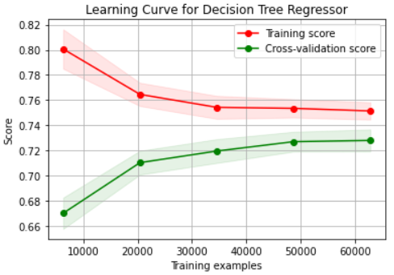

For the boosted Tree:
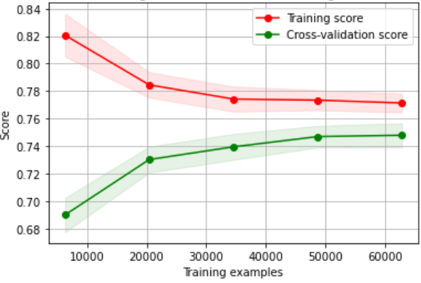
We evaluate the model based on the score. As such, a higher score indicates better performance. We observe the training score decrease and the validation score increase. The gap closes gradually as the training examples grow.

In low bias (high variance), the model captures most of the differences (even the minor ones) between the different training sets. The model fits the training dataset very well as revealed by low training errors, but training errors might be so low, that we can be increasing the gap between training and validation errors, leading to high variance. Here, validation errors may be high. In high variance, there is a wide gap between training and validation errors , and the model is said to be overfitting.
In our case, the gap between training and validation is not big (0.75 and 0.73 for regression, and 0.76 and 0.74 for boosted),so we can say that the model is able to generalize well. At the same time, the data is not fitted well enough by the fitted model since the training error is not negligible. The narrower the gap between training and cross validation scores, the lower the variance. High validation error can also indicate a bias problem, which may lead to underfitting and not being able to generalize well to the relationships between the variables. In our case above, the variance is considered low, but the bias is a bit high.
Next, we scale your input data using MinMaxScaler(), while making sure that our scaling procedure avoids data leakage.
Next, we define a new model again and train it on the training data and evaluate its performance on the testing data. We write the code to:
1. Initialize a new DecisionTreeRegressor() and GradientBoostingRegressor() model, plug it in with the best set of hyper parameters you got earlier.
2. Train this model on the training data
3. Test the model on the testing data, and get the predictions.
4. Evaluate the performance of the model using 𝑅2, 𝑅𝑀𝑆𝐸, 𝑀𝑆𝐸 and 𝑀𝐴𝐸

The results are as follows, for the regression tree:
R2: 0.72971
MSE: 62.68374
RMSE: 7.91731
MAE: 5.88885
The results are as follows, for the boosted tree:
R2: 0.734371
MSE: 61.7814
RMSE: 7.860
MAE: 5.7771

Next, we select the top 10 features using RFE, we get the following:

feature | ranking
30 | whc | 1
19 | Value of Previous Year | 1
18 | Crossed Weather | 1
22 | clay | 1
29 | tfactor | 1
20 | Yearly Average Temperature | 1
26 | sand | 1
25 | om | 1
28 | spH | 1
21 | Yearly Precipitation | 1
24 | kwfactor | 2
27 | silt | 3
17 | Crossed Soil Composition | 4
23 | kffactor | 5
4 | CountryBit_4 | 6
3 | CountryBit_3 | 7
6 | CountryBit_6 | 8
5 | CountryBit_5 | 9
14 | CountyBit_7 | 10
1 | CountryBit_1 | 11
12 | CountyBit_5 | 12
9 | CountyBit_2 | 13
15 | CountyBit_8 | 14
11 | CountyBit_4 | 15
13 | CountyBit_6 | 16
10 | CountyBit_3 | 17
2 | CountryBit_2 | 18
8 | CountyBit_1 | 19
16 | CountyBit_9 | 20
0 | CountryBit_0 | 21
7 | CountyBit_0 | 22

After that, we subset the X_train and X_test to include only the selected features by RFE

Fitting After Feature Selection
Now we define a new model again and train it on the new subset of selected features and evaluate its performance on the testing data. We write the code to:
1. Initialize a new DecisionTreeRegressor() and GradientBoostingRegressor() model, plug it in with the best set of hyper parameters you got earlier.
2. Train this model on the subsetted training data (that includes only the features selected by RFE)
3. Test the model on the testing data (that includes only the features selected by RFE), and get the predictions.
4. Evaluate the performance of the model using 𝑅2, 𝑅𝑀𝑆𝐸, 𝑀𝑆𝐸 and 𝑀𝐴𝐸
We get the following results, for the regression tree
R2: 0.72548
MSE: 63.66526
RMSE: 7.97905
MAE: 5.94914
For the boosted tree
R2: 0.73672
MSE: 62.78631
RMSE: 7.92378
MAE: 5.85727

We notice that the accuracy slightly got reduced, but the same for MSE and RMSE. However, MAE slightly increased. Here, the feature selection resulted in the loss of predictive accuracy. However, if we see the difference between the result before and after feature selection, the underlying principle here is that the features selection is able to reduce the dimensionality of the predictive models. The dimensionality depends on the dimensions of the data. So, while the dimensionality of the model decreases, the complexity of the model also decreases. This eventually leads to a faster model training time and convergence.With enough justification on the approach, I can live with a -2% of predictive accuracy while I can greatly reduce the model complexity, training time and overfitting while increasing the generalization ability. RMSE was slightly reduced, this is to reduce the “metrics bias” and help us to see the bigger picture of the evaluation results rather than focusing only on the accuracy.

Regression Model

First Fit

For our dataset, we have the target variable Y which is the Value of wheat (in bushels/acre) per year. All the rest of the features in our dataset are treated as input variables for our regression problem.

We apply the linear regression model to our training data, and we fit our model onto our training data.

We then use the predict function for the prediction of the Y values of the testing data. We compare the y_predicted values with the original Y values of the testing data and calculate the accuracy of our model, which is implemented by r2_score, whose value ranges from 0 to 1.

We calculate the r2 score, mean squared error, and the root mean squared error.

r2 score is 0.8694471843647684
mean_sqrd_error is== 30.188095165174424
root_mean_squared error of is== 5.494369405598283

Learning Curve, Bias, and Variance
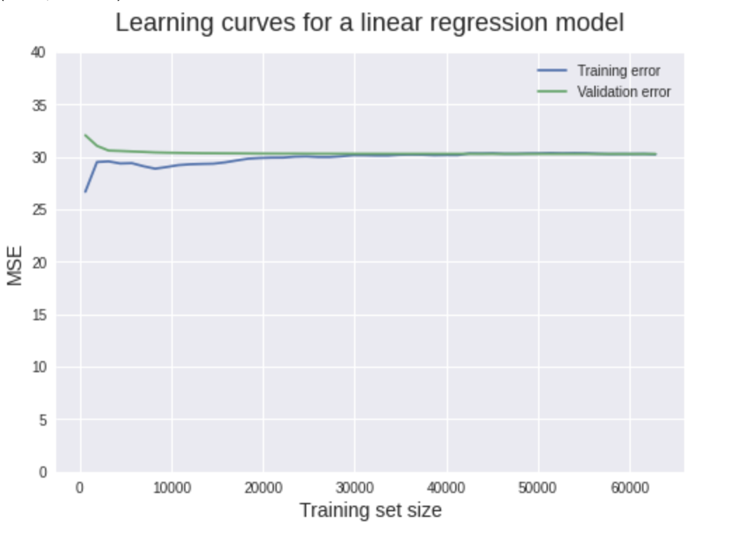

Model Evaluation
We evaluate the model based on the score. As such, a higher score indicates better performance. We observe the training score decrease and the validation score increase. The gap closes gradually as the training examples grow.

In low bias (high variance), the model captures most of the differences (even the minor ones) between the different training sets. The model fits the training dataset very well as revealed by low training errors, but training errors might be so low, that we can be increasing the gap between training and validation errors, leading to high variance. Here, validation errors may be high. In high variance, there is a wide gap between training and validation errors , and the model is said to be overfitting.

In our case, the gap between training and validation is almost 0, so we can say that the model is able to generalize well, and it is not overfitting. At the same time, the data is not fitted well enough by the fitted model since the training error is not negligible. However, an 86% accuracy isn’t bad in our case, the best performance among all other models. The narrower the gap between training and cross validation scores, the lower the variance. High validation error can also indicate a bias problem, which may lead to underfitting and not being able to generalize well to the relationships between the variables. In our case above, the variance is very low, and the bias is a bit higher, but also low.

We performed the similar data science pipeline used for the regression tree. We used the MinMax Scaler to scale our data and we performed a grid search, and did a 10 fold cross validation.

Fitting After Feature Selection
Similar to the Regression Tree, we did Hyperparameter search for the regression model,
We get the best parameters to be:
'copy_X': True, 'fit_intercept': False

We fit the model again, we get 87% accuracy. We get the results:
R2: 0.86994
MSE: 63.32699
RMSE: 7.95783
MAE: 5.94846

We pick the top 10 best features using RFE, and fit the model again. The accuracy is back to 86 %
R2: 0.86155
MSE: 64.57663
RMSE: 8.03596
MAE: 5.995850

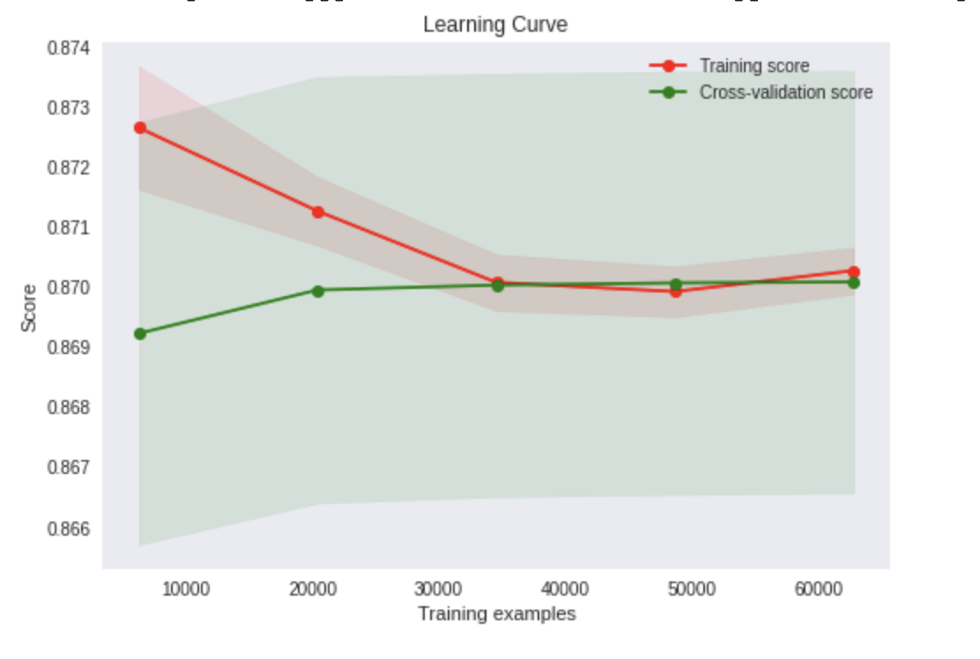
After picking the top 10 features, the accuracy got slightly reduced, but the MSE, RMSE and MAE slightly increased, so we could say the model has a slightly worse performance. However, we reduced the features from 22 down to 10. Thus, the model got simpler (similar to the explanation of the regression tree).

Deep Neural Network

For our neural network, we decide to implement a fully connected FNN.

Model Analysis and Model Evaluation
For our model, we start out with an input layer, two hidden layers of 32 neurons and ReLU activation, and an output layer with ReLU activation. We decide to go with one output node and a ReLU function for the output layer because our problem is a prediction problem, and so we will have one node that contains a numerical value for the prediction.

We get as results:
MAE: 11.129848941957185
MSE: 195.46331260582696
RMSE: 13.980819454017242
R-Squared: 0.17762095590540172

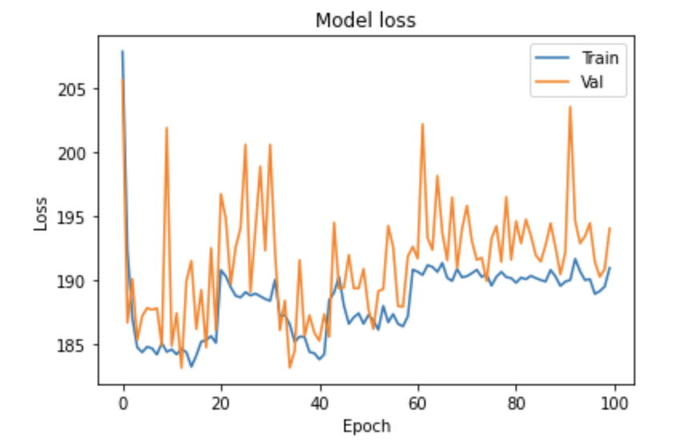
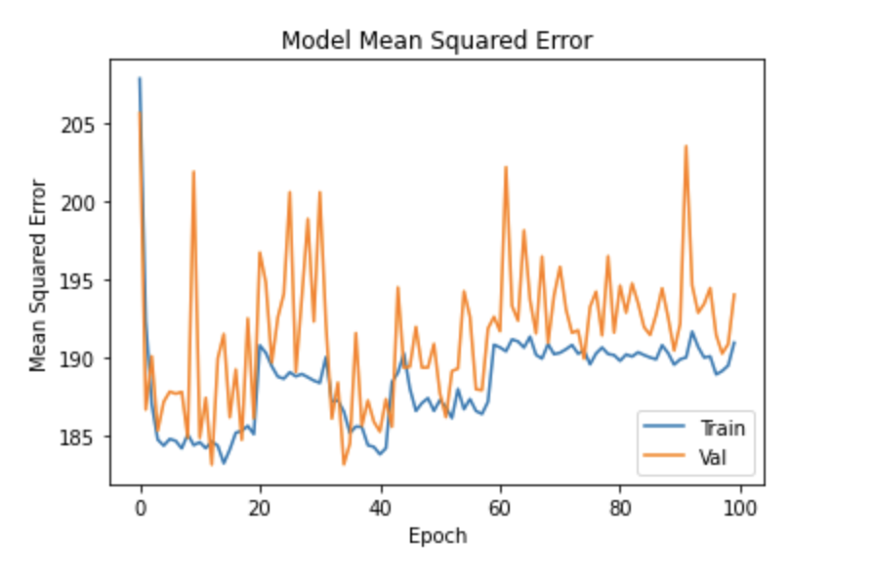
After that, we decide to add L2 regularization which tries to estimate the mean of the data to reduce the chances of the model overfitting, and we do so by including the squared values of the parameters in our overall loss function, and weighing them by 0.01 in the loss function (kernel_regularizer=regularizers.l2(0.01)), and by adding a new Dropout layer like (Dropout(0.3)) which drops neurons in the previous layer with a probability of 0.3.

We get the following results:
MAE: 11.180737241214544
MSE: 205.40438448071274
RMSE: 14.331935824609065
R-Squared: 0.13579556638982182
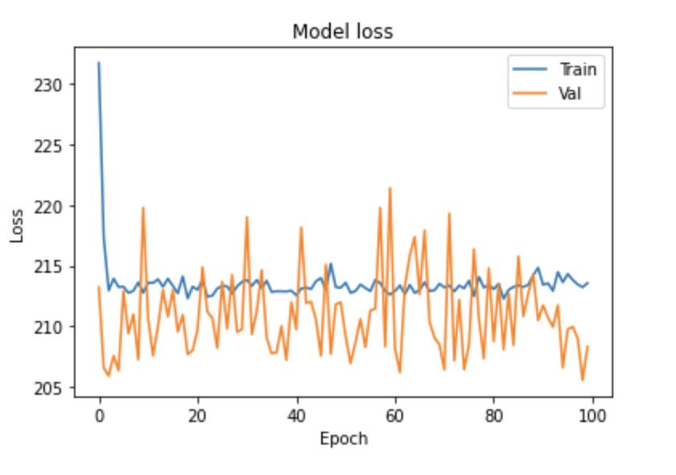
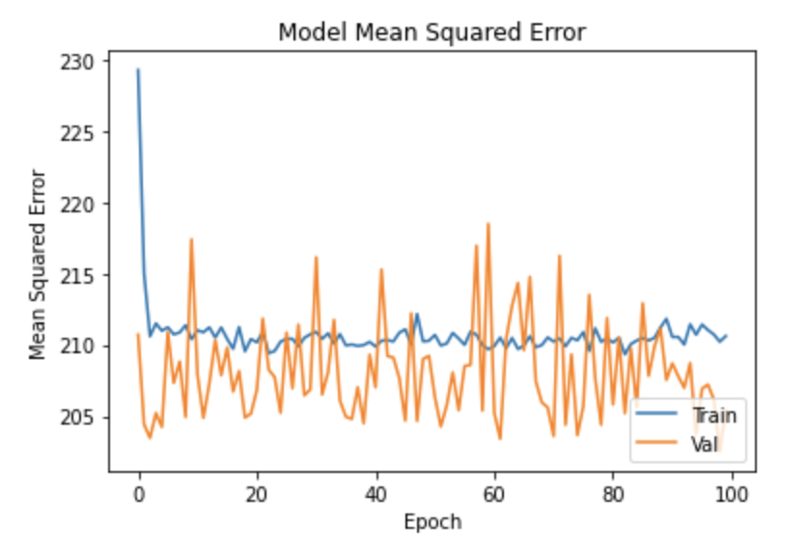

Comparing the graphs and our results, we observe that previously we had a lower loss than when we use dropout, and we also previously had lower mean squared error. This is because our model is not really overfitting in the first place, and so using dropout does not necessarily make it perform better.

In order to make our model performance better, we will tune the hyperparameters.

Cross Validation and Hyper Parameter Search
For a neural network, we have many hyperparameters we can tune.
In model creation, we can tune the number of hidden layers, the number of nodes in these layers, and the activation function.
While training, we can tune the batch size and number of epochs.

We do so in two different stages, and obtain the following:

Hyperparameter to be Tuned | Alternatives | Optimal Parameter
Neurons | 10, 15, 32, 64, 128 | 64
Activation | ReLU, Linear, SIgmoid | ReLU
Batch Size | 10, 50, 100, 200, 300 | 300
Epochs | 32, 64, 128 | 32

We used 3-Fold cross validation and grid search (because more folds were very time consuming). The optimal parameter is chosen by trying every combination of values give (alternatives in the table above) with each other and performance metrics (score) is calculated for each. The optimal parameters are chosen based on the best score.

We then create and tune our model based on the previous outcomes, and obtain the following results:

MAE: 10.048811785042984
MSE: 159.0876086775517
RMSE: 12.612993644553688
R-Squared: 0.330665617975205

We get a lower MAE, MSE, and RMSE, and higher R squared.
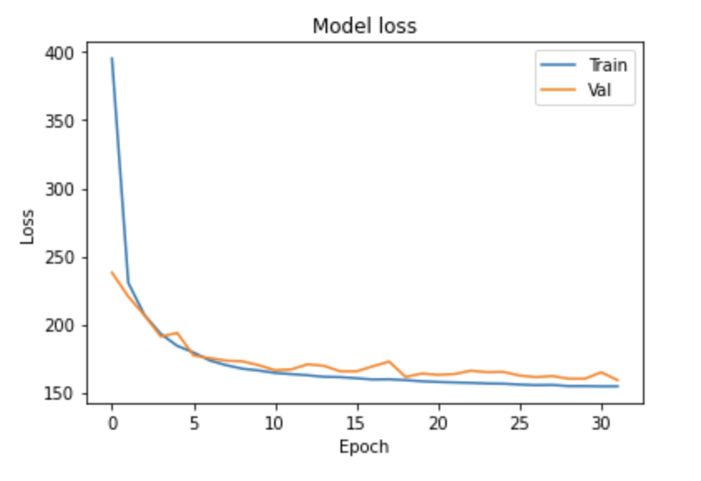

Learning Curve, Bias, and Variance

For the graph above displaying model loss for training and validation, we observe a graph with a good fit. The model does not overfit or underfit, and the training and validation loss decrease to a point of stability with a minimal gap between the two final loss values. This shows that the model does not overfit.

The loss of the model is lower on the training dataset than the validation, and this is observed by the small gaps between the two curves.

This model does not overfit because the training loss is high at the beginning and then starts to decrease until it reaches a “flatter” portion, versus the curve being low for an overfit model which gradually increases very slightly upon adding training examples and doesn’t flatten). Moreover, the validation loss also flattens indicating no overfitting. So, since this model does not overfit then it does not have high variance.

This model has low bias too because it does not underfit, because training loss does not increase upon adding new features, but validation loss fluctuates a bit and is seen to increase a bit at times and then decrease again. So, this model has a bit of a bias but it generally represents a good fit.

Fitting After Feature Selection
After selecting the top 3 features of "Crossed Weather", "Value of Previous Year", "Yearly Precipitation" , we decide to refit the neural network on these features.

We get the following scores:

MAE: 5.820394409280011
MSE: 61.63738846199645
RMSE: 7.850948252408523
R-Squared: 0.7342241909081526

And the following loss graph:

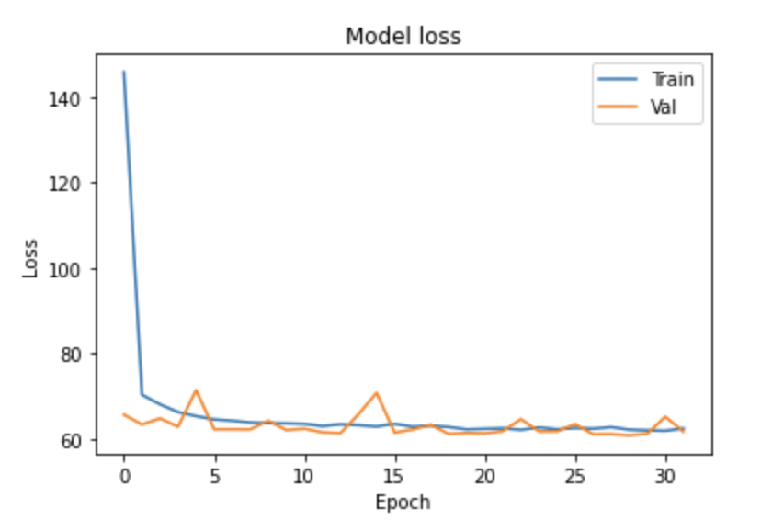
We can see that the model performed better on the top 3 features versus on all the features, because it is now focusing on features that are more relevant to predictions and have more weight in influencing the outcome.

The MSE, RMSE, and MAE are all lower indicating a better performing model, and the training curve is smooth as it decreases reaching a plateau. Moreover, the validation curve is lower than the training in some portions which reflects positively on the model, and the model loss starts high and decreases fully indicating it is properly learning.

Support Vector Machine

The SVM algorithm is an unsupervised learning model that is mostly used for classification applications, but it can also be used for regression and in such cases it is referred to as Support Vector Regression (SVR). SVR will help us predict discrete values, which in our case is the wheat yield (in bushels/acre).

The straight line that is required to fit the data is referred to as the hyperplane. The main goal of using an SVR is to find a hyperplane in an n-dimensional space that distinctly classifies the data points. The data points closest to the sides of the hyperplane are called Support Vectors. Our goal is to find this hyperplane (the best fit line) which has the maximum number of points.

SVR is different from other regression models because it tries to fit the best line within a threshold value, which is the distance between the hyperplane and boundary line. (versus trying to minimize the error between the real and predicted value)

Model Analysis and Model Evaluation
We fit the model on all the test data columns, and obtained:

MAE: 9.492433199279692
MSE: 163.08958693520785
RMSE: 12.77065334801661
R-Squared: 0.31382796690840065

The plot of the predicted vs actual values is:
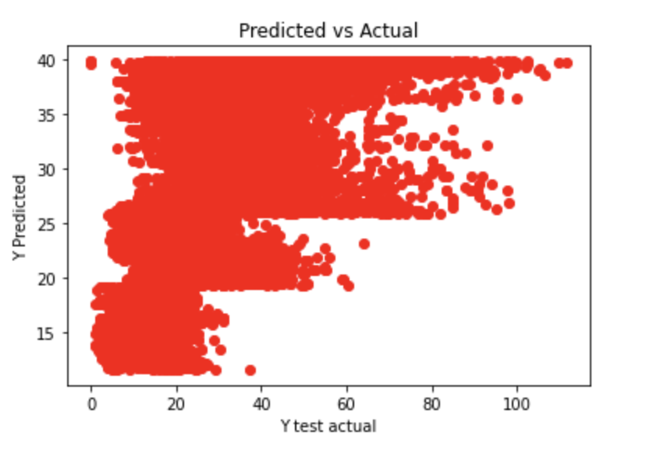
For the ideal case, the actual should be as close as possible to the predicted case (represented by the line y=x). As such, our points should be close to a regressed diagonal line.

We plot the y=x line, and plot the points based on density concentration, and obtain the following:

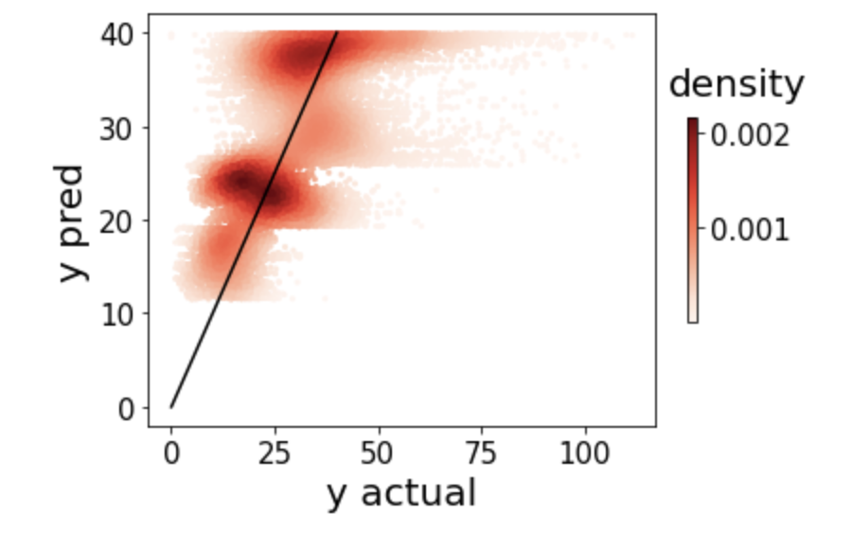
Because we have so many data points, in order to better visualize their locations, we decide to plot the points based on their density, where darker colors represent more concentration of points and lighter ones represent less concentration.

As such, we can see that more points are situated around the y=x bisector, and so the model predictions are somewhat close to the desired ones in some cases. However, it is important to note that we do have several predictions that stray away from the main bisector, and so the model is, of course, still not optimal. We will now use hyperparameter tuning and feature selection to try and make the model performance and predictions better.

Cross Validation and Hyper Parameter Search
Some of the main hyperparameters in SVR are:

- Hyperplane:
The hyperplane is the decision boundary that is used to predict the output. The support vectors (data points that lie on either side of the hyperplane) help to plot the line that demonstrates the predicted output.

- Kernel:
The kernel (a set of mathematical functions) takes the input data and transforms it to the required form. These kernels are used to find a hyperplane in the higher dimensional (n-dimensional) space.
The kernels can be: linear, non linear, polynomial, radial basis function (RBF), sigmoid…

- Gamma:
The kernel coefficient for the chosen kernel.

- Boundary Lines/ Epsilon Value:
The boundary lines are used to create a margin between the data points.The are drawn around the hyperplane at a distance e (epsilon value) away from the hyperplane.

- The C Value:
It is the regularization parameter. The strength of the regularization will be inversely proportional to C, and the penalty is a squared l2 penalty.

Hyperparameter to be Tuned | Alternatives | Optimal Parameter
Regularization Parameter (C) | 0.1, 1, 10, 100, 1000 | 1
Gamma | 1, 0.1, 0.01, 0.001, 0.0001 | 0.001
Kernel | RBF, Linear | RBF

We decide to perform hyperparameter tuning with 10-fold cross validation, and we get that the best parameters are:
C=1, gamma=0.001, kernel=rbf;, score=0.658

We do this by using Grid Search, where the domain of the hyperparameters is divided into a discrete grid and every combination of values of this grid is tried out and performance metrics (score) is calculated, where the optimal parameters are chosen based on the best score.

We fit the model using the best parameters found, and we get the following graph:
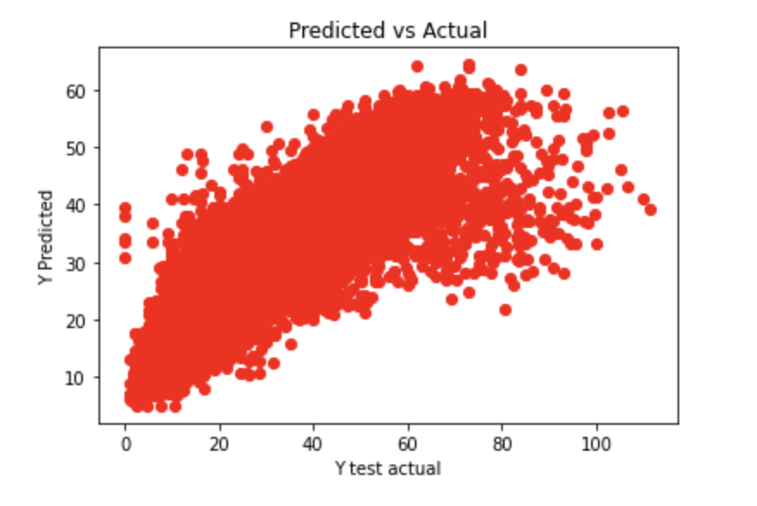
And the following density plot:
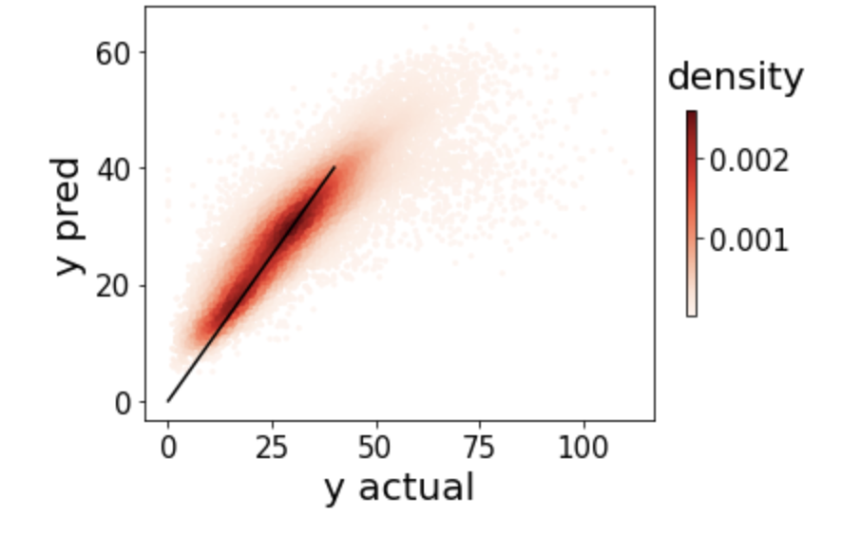

We can see that the predicted and actual are very much centered around the y=x bisector, which strongly reflects that the chosen hyperparameters fit the model better and produced more accurate predictions.

The scores of the model are also obtained:

MAE: 5.748271896175723
MSE: 79.12354426805179
RMSE: 8.895141610342794
R-Squared: 0.6671009826188872

vs. previously:

MAE: 9.492433199279692
MSE: 163.08958693520785
RMSE: 12.77065334801661
R-Squared: 0.31382796690840065

Compared to the previous scores, we now have a lower MAE, MSE, and RMSE. The lower the values of the MAE, MSE, and RMSE usually implies a higher accuracy of a regression model. This is because these metrics measure the difference between the actual and predicted values, and so we want them to be as close to each other as possible to get the best and most accurate predictions. So, with the values being closer to each other (as seen in the second density plot where most of the points are clustered close to the y=x bisector), the difference in their values will be smaller, and so MAE, MSE, and RMSE are smaller.

R Squared is used for explaining how well the independent variables in the linear regression model explains the variability in the dependent variable. It explains how well the regression model fits the observed data, and so a higher R squared value is better as it indicates a better fit for the model.

Learning Curve, Bias, and Variance
Plotting the learning curve for SVM was consuming so much time, so we could not have a visual for it. Instead, we assess the model based on the C value and discuss the learning curve in general.

The “tuning/regularization parameter” C (or regularization parameter) is used to help us avoid overfitting.

When the model fits too closely to the training data, it overfits, by performing very well on training data but very poorly on the validation data. To optimize this error, we use regularization and tune C so that we can keep the parameter regular or normal. By specifying a value for C, a regularization term is added to the loss function to overcome the overfitting line and improve prediction accuracy.

Large values of C means a higher penalty, leading to a less complex model, meaning it will generalize better but we will have high bias, while smaller values of C constrain the model more, leading to a lower penalty and a more elaborate model as it fits the training data better. This may lead to a model with low bias that may not necessarily generalize well, and have high variance, leading to overfitting the training data.

For optimal learning curves, the training error should start from 0 and increase, and validation error should start from 100 and decrease. A high training error indicates high bias which is underfitting, and a low training error indicates a low bias (high variance) which is overfitting. So, we want our model to have both low bias and low variance so that it does not overfit or underfit.

In this case, we try to look for the optimal C that gives us the most feasible (preferably least) error which does not lead to overfitting or underfitting the model. In our hyperparameter search, we got C=10. (Ideally we would have plotted for C=10 and a lower or higher value to note how the learning curves vary and display more bias or variance based on our explanation above).

Fitting After Feature Selection
Using feature selection we chose the top 3 features ("Crossed Weather", "Value of Previous Year", "Yearly Precipitation") and plotted them, and we can visualize the 3D hyperplane below:

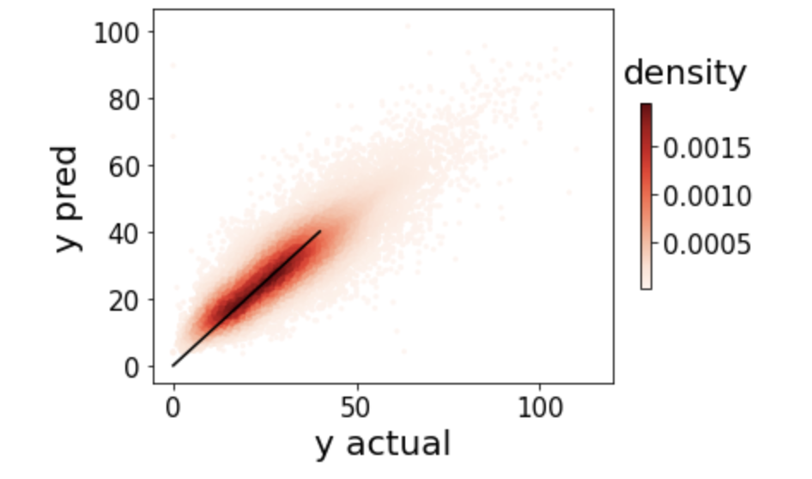
After fitting the model (using the best parameters chosen above), w can observe that most of the predictions are clustered around the y=x bisector, meaning that most of the predictions are closer to their actual values now.

We also get the following scores:

MAE: 5.939178605862768
MSE: 63.84862228241935
RMSE: 7.990533291490584
R-Squared: 0.7246895160561104

We have a lower MSE and RMSE than previously, and a higher R2 indicating that we have a higher accuracy of our regression model because the difference between the actual and predicted values is less, meaning that they are predicted more closely to each other.

We plotted the 3D plot and included the interactive version in the submission file. Here are some screenshots from different angles where the x-axis represents Crossed Weather, the y represents Value of Previous Year, and the z axis represents the y_predicted.

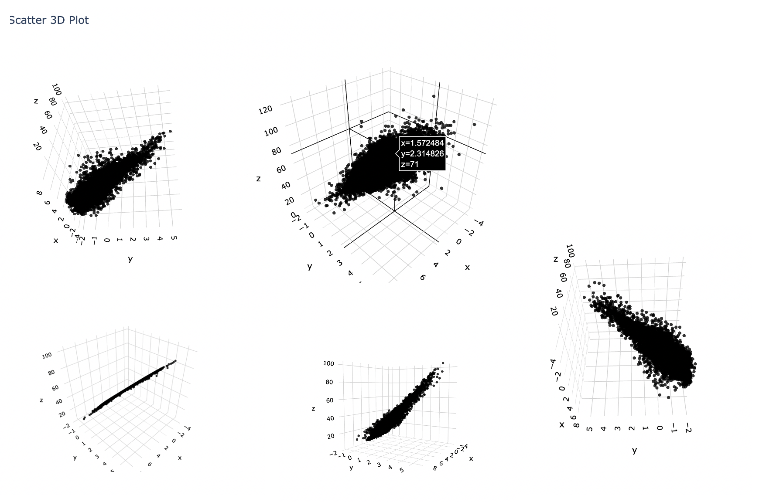

Project Wrap Up

In this project, we were able to achieve a good predictive ability for wheat yields. Such a predictive ability is very important from many perspectives. First, it would allow farmers to predict the crop yields of coming years in such a way that they would be able to eliminate uncertainty from crop productions. Also, if the predictive power of this model gets high enough, we would be able to integrate it with other models such as weather models, soil assessment surveys etc. in order to predict future development of crop yields.

The most important limitation of this project is the fact that crop yields are dependent on very precise measurements of sensitive data. Small changes in the data incur big changes in the crop yields. This present complexity that we observed was complemented by a lack of available and precise datasets. For example, the only soil survey data that we found were for the years 1996, 2001, 2006, and 2011. As such, we had to impute values for the other years. Imputing this way does not present a big challenge over years that are close to each other, as soil characteristics generally change very little on the timescale of years, however, they do very much change on the timescale of decades. Another improvement that could be done is to add more columns to the dataset. A good column to add is the minimum and maximum temperature of each year in each county. While it is true that the average temperature does tell us about the crop yields, the minimum and the maximum would be able to inform us about potential spikes in crop yields. This is a consequence of the fact that crops are very sensitive to high and low temperatures. That is, after a certain threshold whole crop fields will be annihilated because of high or low temperatures. As such, we deduce that our project definitely suffers from the quality of data.

Our project can grow across many dimensions. Firstly, we could add more data, and ensure it is of good quality and precise measurement. Secondly, we could add more details to hyperparameter tuning and tune our models even more. Lastly, we could apply our project in a real-life scenario and get feedback from clients, and based on that we can know what other important aspects we missed that we could further implement.

In the case of modeling, we think that our methods were appropriate to the problem. This can generally be seen with a good predictive ability even for simpler types of models such as linear regression. In fact, linear regression in our case seems to have an unreasonable effectiveness. This is probably caused by the most important feature in our dataset: the value of the previous year. One can come to the reasonable conclusion that this value that tells us a lot about future yields, shares a very high correlation with the value we are trying to predict. However, if possible, such a value in the future should be eliminated. The purpose of such an elimination is warranted from the fact that using such a value would not enable us to generalize the model to future farming endeavors which are unexpected.

Some limitations such as data availability can hardly be controlled by a data scientist. The quality of data, and availability of data are generally produced by national surveyors that have a limited reach. However, in the future, we might see an improvement in the data availability of certain attributes due to the interest of the farming researchers and communities in IOT devices. Furthermore, some features are inaccessible to us, such as pesticide, insecticide, grains used, etc. as those “recipes” are generally kept secret in the bigger farming communities.

In conclusion, this project can definitely grow to be applied in real life situations.

